NAME: A.RAFAY

CMS: 023-22-0355

LAB:1

Week 1 Lab – Network Utilities

Windows Network Utilities

Objective – To learn network utilities/commands

Note – After performing the lab activities, write your observation, response or paste a snapshot

For a computer to be a part of Network,

1. Hardware - A Network Interface Card (NIC) is a must. It can be Ethernet LAN Card (Wired) with a connector Jack or a Wireless Card (Wifi)
2. Software – An Operating System supporting networking, now all OS support TCP/IP, and Ethernet
3. Network Configuration – A logical IP address, subnet mask and a gateway

Example:

IP address: 192.168.0.1

Subnet mask 255.255.255.0, this shows what is network number and what is host number

Utilities or commands that you will learn

Ping

Ipconfig or ifconfig

Nslookup

arp

Tracert

Netstat

route

Activities

**Network Interface  
1. Know your communication interface  
unplug the RJ 45 or ethernet cable or UTP cable  
replug the connector and observe the connectivity process**

**Now find following  
host name of your PC**

Command

hostname

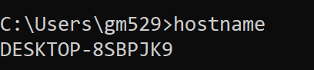

**# of interfaces (virtual and physical)**

Command

Ipconfig /all

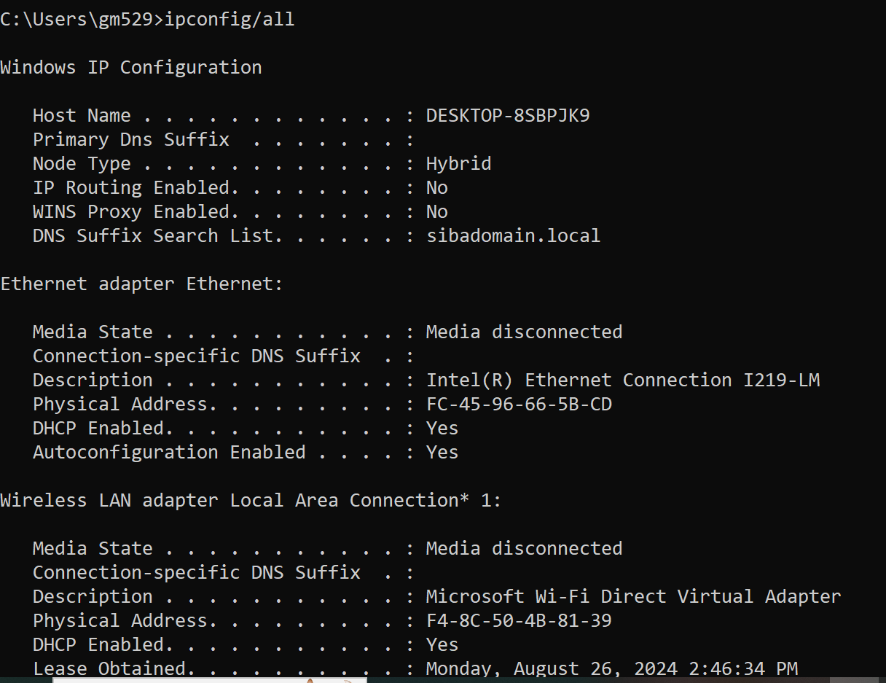

**IP address of your PC**

Command

Ipconfig

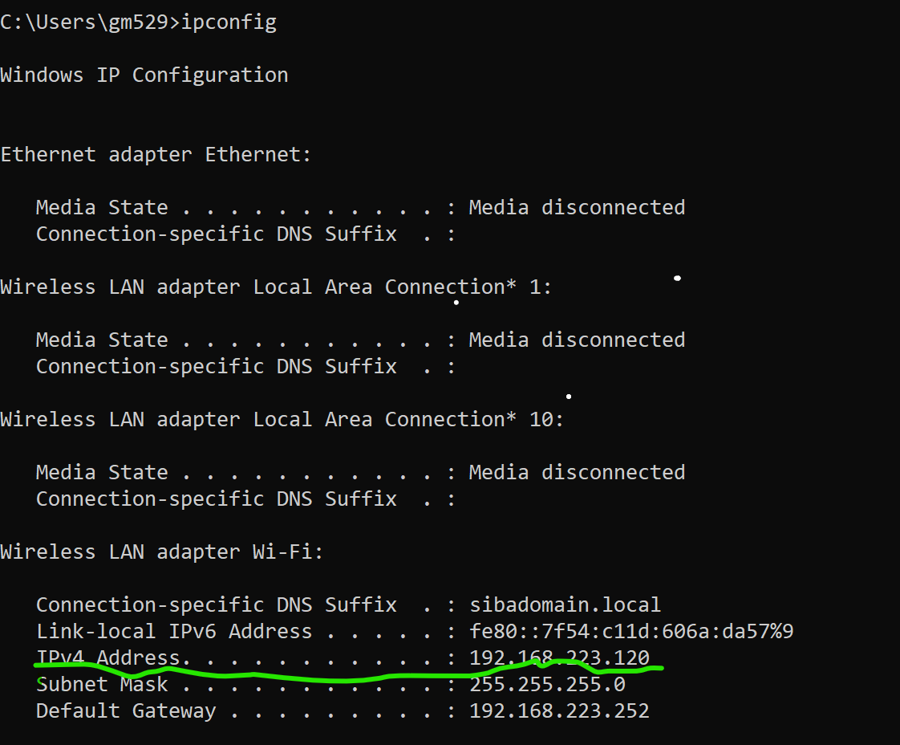____________________________________________________________________

**DNS server : how many? which is primary? which is public and which is private  
  
Lets ping our neighbors  
ping an IP**

For checking ip address for foreign and local address

Command netstate

Command

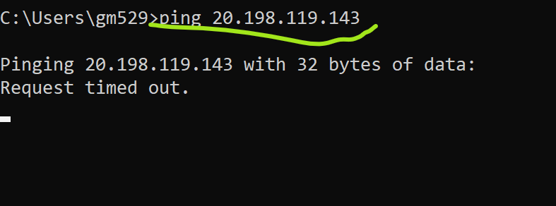

**ping a hostname**

_ ___________________________________________________________________________________

**ping with -n**

To send the number echo to other device

Command

Ping –n count here count is how many packets we want to send than ip address

________________________________________________________________________

**ping with -t**

it means packets will send continuously until manually not stop we stop with ctrl+C

Command

Ping –t ip address

_____________________________________________________________  
**lets use name server (dns) to know IP address of** [**www.centralasian.uz**](http://www.centralasian.uz)

Command

We use nslookup to find ipaddress

nslookup [www.centralasian.uz](http://www.centralasian.uz)

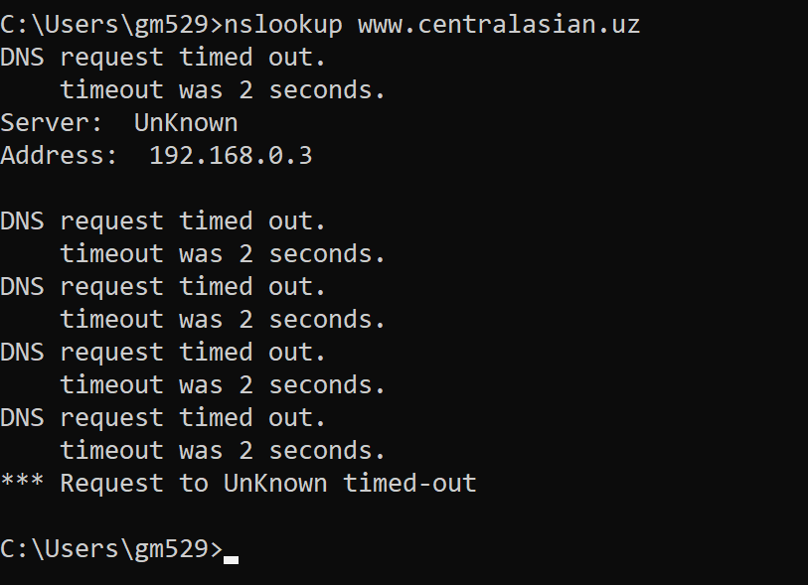  
__________________________________________________________________________

**lets trace** [**www.google.com**](http://www.google.com)

command

nslookup [www.google.com](http://www.google.com)

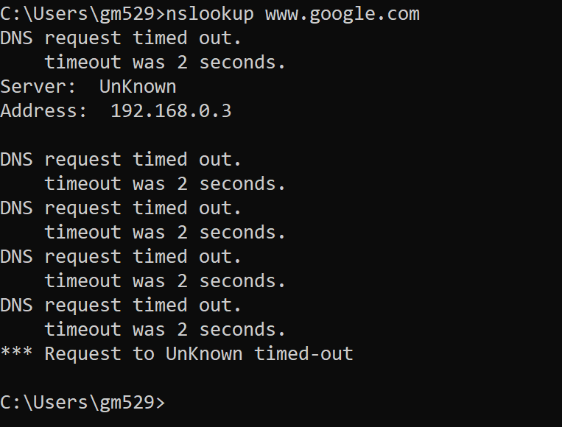

_________________________________________________________________________

Additional Material

Mac OS

####ifconfig ifconfigshows network interface information, such as interface name, tpye, IP address, Mac address, etc.

####host host www.google.com return domain's ip address.

####ARP arp -a show local IP-Mac matches

sudo arping -I eth0 192.168.1.1 send ARP request via eth0 to find Mac address of 192.168.1.1

sudo arp-scan -l search Mac addresses for all IPs in the LAN.

sudo tcpdump -i en0 arp listen en0 port for arp data.

####Network ping 192.168.1.1

sudo ipconfig set en0 DHCP renew DHCP lease(will get a new ip address).

sudo ipconfig set en0 INFORM 192.168.1.123 set a static IP address.

####Router netstat -nr show route table(includs gateway).

traceroute 74.125.128.99 trace the full route to 74.125.128.99

sudo traceroute -T -p 80 74.125.128.99

####Network listen sudo tcpdump -i en0 listen everything on en0 port.

*Disclaimer: The lab guide/instructions/manual has been compiled by taking help/content from various textbooks and public Internet resources for Educational purposes.*